GYLA General Meeting August 20, 2022 Minutes

Meeting called to order at 10:02 am by Peter Paffenroth, President. 24 people present.
Pete gave a nice welcome and prayer to begin the meeting.
Secretary, Brenda, read the minutes from the August General Meeting. Brenda motioned that they be accepted, Bruce 2nd, All Approved.
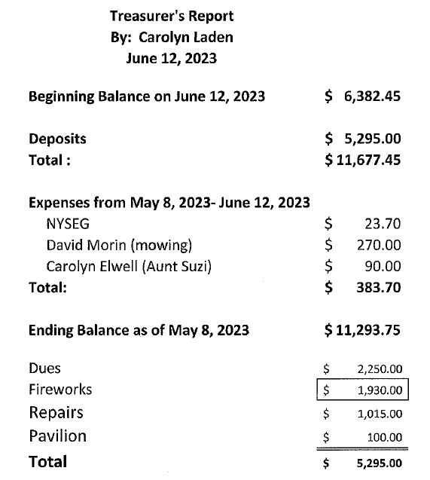
Treasurer’s Report- Carolyn Laden Read:

Old Business:
Membership Applications- Carolyn Elwell announced that she had print outs of the new application, if you know a member that had not gotten one in the mail or have a new neighbor, please take some to hand out.

Clothing- Carolyn Elwell presented all of the clothing and the new price list (below)

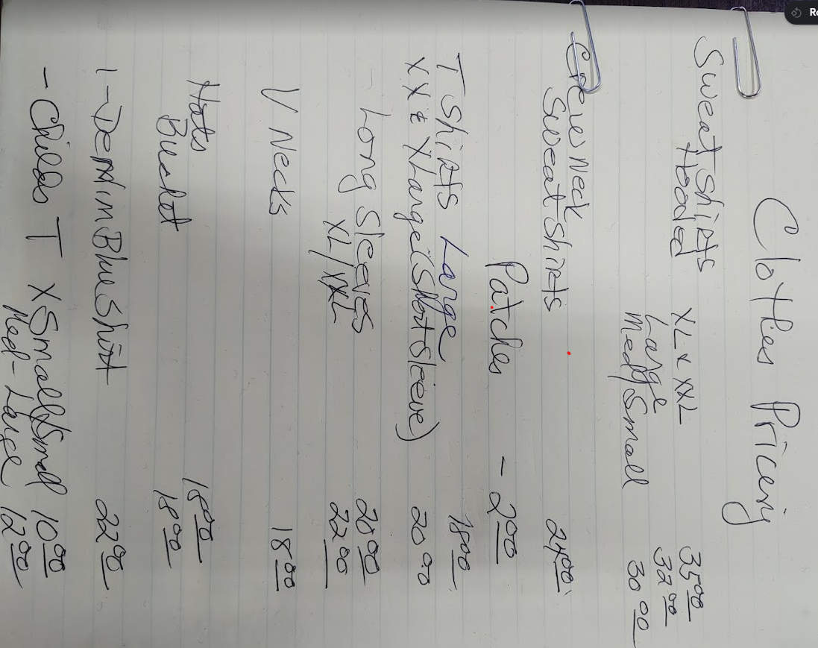

Dry Hydrant Report- Pete has spoken with Henry Kroll. Henry is offering to dig the dry hydrant free of charge, GYLA will pay for the Supplied and piping, we hope to assemble in August. Pete will meet with eh Fire Chief to set up an installation date and discuss getting the rest of the Dry Hydrants blown out and tested for working order.

Journey’s End- Art Henry reported that Pete Paffenroth obtained paperwork from the county and town that Art has given to our Lawyer. Art explained that the issue with Journey’s End and some of the right of Ways is that the Street transfer in 1962 to the town of Milford was not done correctly and those properties went with the roads. Journey’s End was deeded along with Lee Drive. There are 10 right of ways, we only have 4 of those deeds. So far costs of just under $1,000 to the lawyer and to the Abstract Company have been paid by Art and GYLA has reimbursed him. Art stated that Liability insurance will be needed on all 10 of the right of ways, the quote is $1,800 annually. Art promised to give a more complete report after meeting with the lawyer, Peter Hobiaca.
Building Fund/Pavilion- Art reported that the fund has been oved to the Wayne County bank for a term of 18 months at 4.45% interest. Ellen asked if there was a vote to reinstate the building of a pavilion, as she remembered it being voted down. Brenda to check minutes to see if a vote was taken to reinstate the pavilion.
New Business:
Nomination Committee-Jean Lilja reported that the presidents and secretary seats are up for election this year, Pete and Brenda expressed their interest to continue in these roles. 3 board seat terms are up- Neal and Mindy wish to run again, Art would like to run also as Linda Culp would like to step down. Ellen Schmidt would also like to step down, if you have a nomination, please get it to the Nomination committee before the July General meeting.
Roads- The town of Milford came through and measured the roads and came back to widen certain areas, remove encroaching brush and restore soft shoulders. Areas corrected are 2 places on Lake Shore North, Radley Road and Maple Dr. The issue is that the plows need at least a plow and a half width to pass easily, there are still some rocks, piping and shoulders in the way. This is to be corrected also.
Mindy suggested that we invite the Superintendent to the July meeting to explain the town’s plans. Pete to invite him to our July General meeting. GYLA will send a Thank you note to the Road crew for such good and appreciated work.
Milford Youth Athletics report- Pete reported that we donated $280 to the Milford Youth Athletics, they have put a banner up for GYLA on the ball field and our name appears on the teams shirts.
Fishing Tournament- Pete reported that Henry has given the go ahead for the Milford Athletics to use his field for the Fishing tournament and associated activities.
Otsego County Soil and Water Conservation Invite- Water Quality Committee with Christos Galanoplopus, Brenda read the invite email. Pete and Bruce will set up a meeting wo meet with Christos to discuss representing Good Year Lake on the committee and discuss the lack of a new survey since 2011, and the water depth that is shrinking due to the silt flooding and weed growth.
Road pick up- Went well, much garbage was collected, but placed in incorrect area. County can only pick up on county roads, from now on we have been asked to pile the refuse on 28 at the corner of 28 and 35. Next pick up will be in September. Date to be decided.
Yard Sale Day- it was reported that it was not as busy as usual, it was decided it was due to other communities having their Garage Sale Day on the same date. It was suggested that we move to the second Saturday in June, tabled until next meeting.
Bench on Right of Way #8- Joyce complained that the concrete end bench would spoil her view and that was the only reason they bought the house. Joyce and Bruce have purchased “a nicer looking bench” and it had been delivered to their home. They intend on having it assembles and taken over to the left of the Dry Hydrant (where the old bench was) soon. She stated that they will put their own plaque on saying that they donated it to GYLA. It was decided that the concrete ends can be used down at right of way #10. More to come on the concrete ends.
Joe motioned that the meting adjourn and Bruce seconded.
11:04 the meeting was closed.

Respectfully submitted by Brenda Brooks, Secretary.

Joe Motioned that the Meeting end, Bruce seconded, All approved. Meeting closed at 11:04 am.

