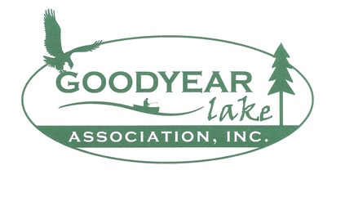
2024 GYLA Membership Application

Please submit by June 25th, mail to: Good Year Lake Association, Attn: Treasurer Carolyn Laden PO Box 62, Colliersville, NY 13747
Name: _________________________________________________________________________
Mailing Address: _________________________________________________________________
Lake Address: ___________________________________________________________________
Home Phone: __________________________________ Cell Phone: ______________________
E-Mail address (required):_______________________________@__________________________
Annual Dues $30 and any donation to the following projects is greatly appreciated:
Fireworks and Boat Parade- Saturday August 10th, 2024 $_______________
Repairs and Improvements on GYLA Accesses $_______________
Survey and Legal Fees: $_______________
We welcome your suggestions and ideas to help Good Year Lake a better home for all of us:
________________________________________________________________________________________________________________________________________________________________________________________________________________________________________________________________________________________________________________________________________________________________________
Volunteer for Events: Yes No Are you available to help with Clean ups or Set ups? Yes No
Please include this slip with your dues. Thank you for joining! Sincerely, The GYLA Board

2024 GYLA Membership Application

Please submit by June 25th, mail to: Good Year Lake Association, Attn: Treasurer Carolyn Laden PO Box 62, Colliersville, NY 13747
Name: _________________________________________________________________________
Mailing Address: _________________________________________________________________
Lake Address: ___________________________________________________________________
Home Phone: __________________________________ Cell Phone: ______________________
E-Mail address (required):_______________________________@__________________________
Annual Dues $30 and any donation to the following projects is greatly appreciated:
Fireworks and Boat Parade- Saturday August 10th, 2024 $_______________
Repairs and Improvements on GYLA Accesses $_______________
Survey and Legal Fees: $_______________
We welcome your suggestions and ideas to help Good Year Lake a better home for all of us:
________________________________________________________________________________________________________________________________________________________________________________________________________________________________________________________________________________________________________________________________________________________________________
Volunteer for Events: Yes No Are you available to help with Clean ups or Set ups? Yes No
Please include this slip with your dues. Thank you for joining! Sincerely, The GYLA Board

