GYLA General Meeting July 17, 2023 Minutes

Meeting called to order at 10:02 am by Peter Paffenroth, President. 25 people present.
Art Henry gave a nice welcome and prayer to begin the meeting.
Secretary, Brenda, read the minutes from the June General Meeting. Joe motioned that they be accepted, Pete 2nd, All Approved.
Treasurer’s Report- Carolyn Laden Read: 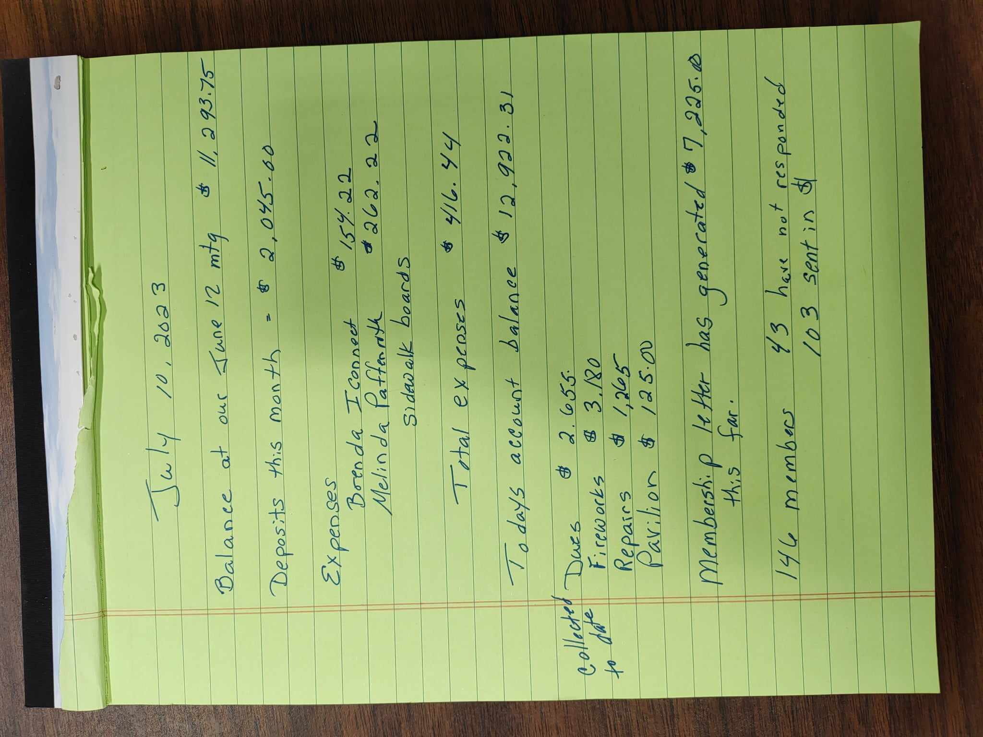

Guest Speaker: Billy Sutfin, Milford Highway Superintendent.
Billy was happy to see so many present. He had a list with the Road Paving Program and the years with him (see below)
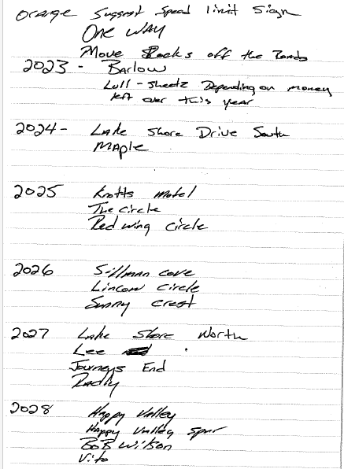
The town will take down the old white 15MPH signs and put up Highly Visible yellow/orange 15 MPH signs, no date as to when that will happen.
Jeremy- Billy’s second in command stated that the state law is 35miles per hour unless it is a school zone, the signs are suggested speed limits, but will not have those words on it. Only official Speed signs are white, all others must be a different color. The general pubic will not know that is merely a suggestion unless they read the New York State Laws.

There have been proposed one ways brought up at the town meetings, it is suggested that GYLA represent themselves at the next meeting, 7/19 at 6:30 to join in the discussion. The proposed one ways are to be revisited as the proposal goes against the mail delivery route.

The town requests that all rocks be moved at lease 3 feet from the edge of the road as the plows keep hitting them. The suggestion is that nothing be 10 feet from the center of the road where at all possible except existing buildings and fencing. The town will be moving the metal posts along Lake Shore South, next to the Willow Point access.

Special Guest: Brian Layman, resident of Barlow Road and works for the DEC but is NOT at the meeting representing the DEC, he is here as a land owner only.
He stated that the DEC is well aware of the weeds and it is widespread across the whole state. The largest weed issues are of the Eurasian Milfoil ad the Coontail Weed- a surface mat weed.
Options/suggestions on weed removal…
Hand pulling, including the roots and laying weeds on land to dry out and then removal of dried weeds to the appropriate garbage dumps.
Purchase a harvester- cost between $80K and $100K. He noted that one lake association purchased one and is selling it after just 3 years, as the members don’t want to assist in the removal process.
Pesticides- The Kinderhook Lake Study is tracking this, Procillifor has been used in the NYS lakes since it was approves in 2017 by the FDA. 32 lakes are currently using it to control weeds. The chemical is active for 2 minutes, just long enough for the weeds to soak it up, then the chemical breaks down into it’s eco friendly ingredients. To be used in combination with Copper- a 2 ½ day half life, stops algae blooms from the decomposing plants.
A bond act has just been passed for Lake Grants, he would like to join a committee to help identify and write grants for GYLA in the Chesapeake Bay Watershed Region.

Old Business:
Reminder the GYLA Fireworks will be Saturday August 12th.
GYLA September end of season picnic has been well attended. Volunteers needed for set up, please let Pete Paffenroth know if you can help. Picnic date September 16th, rain date is the 23rd.
New Business:
Nomination Committee to present elections in August, Jeff Edson is the only new person running for Board to fill the spot Ellen Schmidt is leaving. Jeff spoke about who he is and where he lives and why he wants to help.

Water Quality Meeting attended by Ruth Carlson and Peye and Mindy Paffenroth. Please see Ruth’s notes below…
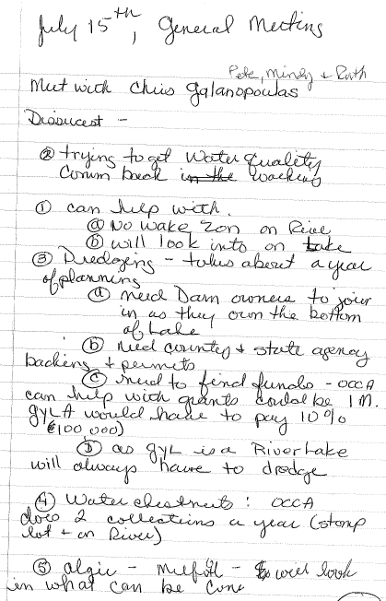

Community Foundation- Jeff Katz is the chai of the Community Foundation of Otsego County- they have open applicants for monies available to the 501C3 organizations in the community. Brenda to apply on the behalf of GYLA for assistanct with the Legal costs of regaining Journey’ss End.

Dry Hydrant Blow out news- Brenda witnesses the blow out on access #8. The Fire Department was going around and testing the hydrants capabilities, #8 did not pass and must be reworked. No other reports on the other 3 dry hydrants of the lake.
Carolyn E. motioned that the meting adjourn and Pete seconded.
10:45am the meeting was closed.

Respectfully submitted by Brenda Brooks, Secretary.

